iCompute Practice Quiz 5/19/17

1. What is the physical structure of a computer called?
- Monitor
- Central Processing Unit (CPU)
- Hardware
- Keyboard

2. Which of the following is NOT an example of "computer hardware"?
- Hard drive
- Monitor
- Keyboard
- Web Browser
- Central Processing Unit (CPU)

3. Which of the following is NOT true of operating systems?
- They are a kind of software.
- They allow different programs to share access to the CPU, memory, and storage.
- They make it possible for users to communicate with software, and for software to communicate with users.
- They are not very important. Computers work just fine without them.

4. Which of the following is NOT an example of "computer software"?
- Microsoft Word
- Minecraft
- Angry Birds for iOS
- Central Processing Unit (CPU)

5. The “short-term memory” that a computer uses while it is running programs to store information that it will need quickly is called __________. This type of memory does NOT retain its contents when the computer is turned off. (2 points)

- Random Access Memory (RAM)
- The Hard Drive
- Read-Only Memory (ROM)
- USB “Thumb” Drive
6. The “long-term memory” that a computer uses to store software programs and data that may be needed in the distant future is called _________. This type of memory retains its contents even when the computer is turned off. (2 points)

- Random Access Memory (RAM)
- The Hard Drive
- A Monitor
- The Motherboard

7. Which of the following CPUs speeds would be the fastest? (2 points)
- 300 MHz
- 2 GHz
- 12 Parsecs
- 1.2 MHz

8. Name three components that you would find inside a computer. (2 points)
[Note: a “component” can be a part of the computer or a separate device.]

______________

______________

______________

9. What is another name for a “set of instructions,” stored on a computer, that can tell computer hardware what to do”? (2 points)
- Manual
- Software
- Flowchart
- Checklist

10. Fill in this table

Binary | Decimal
10 | 2
101
 | 35
11100010
 | 232
1111+1

11. Complete the following flow chart to sort a pile of coins (pennies, nickels, dimes, and quarters) into different bags, one for each type of coin.

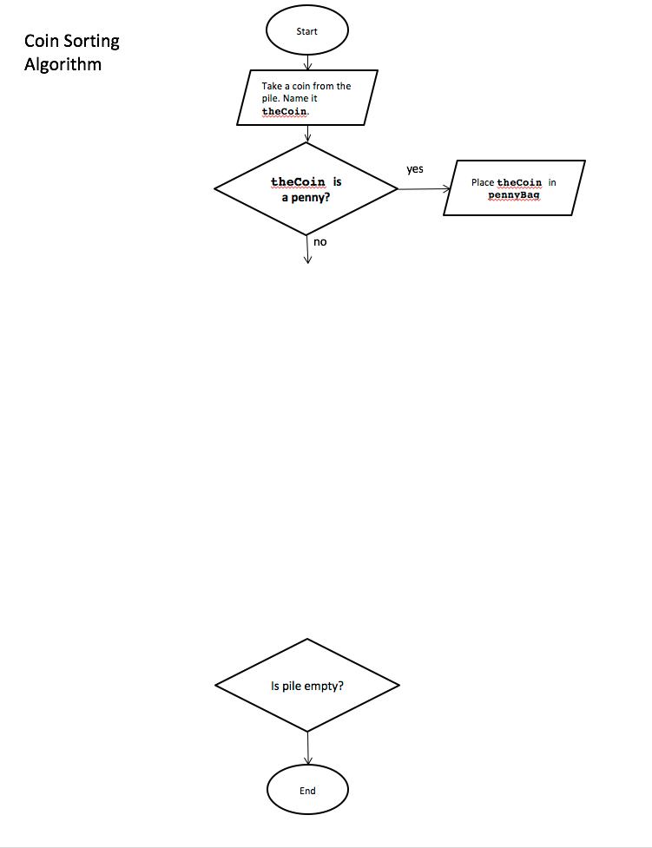

12. Create a Maze Game in which the player navigates through a maze to:

1. Retrieve a key that opens the door
2. Open the door
3. Go through the door to reach a goal
4. When the goal is reached, tell the player that they’ve won.
5. If the goal is not reached within 20 seconds, tell the player that they’ve lost.
f

